## Literature Review

## 

## Project Title: Civic Voice

Group 4 Members Name: Alvin Diamond Johnson

George Soe

Samuel Aloysious Musa

Charles P. Money

Louis L. Gweibeic

## 

## 

## 

## 

## 

## 

## 

## 

### **Introduction**

The proliferation of mobile technology and artificial intelligence (AI) has opened new avenues for enhancing public services, particularly in regions grappling with infrastructural and institutional challenges. This research is important because it seeks to leverage these technologies to bridge the communication gap between citizens and government, thereby improving public service delivery and governance. A comprehensive review of existing literature is necessary to establish the theoretical foundations for the CivicVoice project, identify successful strategies, and ensure the proposed solution contributes meaningfully to the field. This review will synthesize existing research on the application of AI, specifically Natural Language Processing (NLP), in public safety and governance to contextualize the importance and novelty of the CivicVoice app.

Artificial Intelligence (AI) has arisen as a driving technology to revolutionize various sectors, including [finance](https://www.sciencedirect.com/topics/social-sciences/finance), education, healthcare, and transportation. The advanced algorithms and [computational models](https://www.sciencedirect.com/topics/computer-science/computational-modeling) of AI are capable of imitating cognitive functions of human beings like learning, reasoning, and problem-solving. The [interdisciplinary nature](https://www.sciencedirect.com/topics/computer-science/interdisciplinary-nature) of AI encompasses subfields like [machine learning](https://www.sciencedirect.com/topics/computer-science/machine-learning), [natural language processing](https://www.sciencedirect.com/topics/computer-science/natural-language-processing), computer vision, and robotics, contributing to its rapid evolution and widespread adoption. Understanding the present landscape of AI research and development is crucial for harnessing its benefits while addressing ethical, societal, and [technical challenges](https://www.sciencedirect.com/topics/computer-science/technical-challenge).

The growing research in AI witnessed breakthroughs in [deep learning](https://www.sciencedirect.com/topics/computer-science/deep-learning), a subset of [machine learning algorithms](https://www.sciencedirect.com/topics/computer-science/machine-learning-algorithm) inspired by the structure and function of the human brain. AI development revolutionised tasks such as image recognition, speech recognition, and [natural language understanding](https://www.sciencedirect.com/topics/social-sciences/natural-language-understanding) through [deep learning techniques](https://www.sciencedirect.com/topics/computer-science/deep-learning-technique) like convolutional [neural networks](https://www.sciencedirect.com/topics/social-sciences/neural-network) (CNNs) and [recurrent neural networks](https://www.sciencedirect.com/topics/computer-science/recurrent-neural-network) (RNNs). The availability of large amounts of datasets and [computational resources](https://www.sciencedirect.com/topics/computer-science/computational-resource) has enabled the development of [AI models](https://www.sciencedirect.com/topics/computer-science/artificial-intelligence-model) resulting in remarkable performance in real-world applications. (Kulal et al., 2024)

### 

### 

### 

### **AI and Public Safety**

The use of Ai in public safety is transforming how cities approach crime and security. Using capabilities such as predictive analytics, real-time data and natural language processing, Ai helps public safety teams spot risks earlier, respond faster and make it easier for people to get help. These tools are reshaping the future of law enforcement from reactive responses to a more proactive, citizen-focused approach. (*AI in Public Safety: Transforming How Cities Keep People Safe*, 2025)

In times of crisis, an organization's ability to communicate quickly and effectively is crucial for a unified response. Poor communication can cause delays, conflicting information, and a lack of coordination, all of which can worsen the situation and lead to financial and reputational harm.

A strong emergency communication system is the first line of defense during a disruption. It involves predefined protocols and messaging systems that deliver accurate information to all stakeholders in real time, helping to prevent panic and misinformation. This ensures that everyone, from employees to customers, is aligned and knows what actions to take. Ultimately, effective communication is the backbone of crisis management, ensuring a smooth and resilient recovery. (Williams, 2025)

### **AI in Governance**

Government use of AI is a controversial topic, given the power it has and how it might be misused to benefit some and penalize others. However, governments are heavily invested in exploring AI technologies out of both opportunity and risk. There is an opportunity to use AI to improve their citizens’ lives and grow the economy. The inherent risk with AI is that other countries might use it to become more adept at war and economic growth. In certain zero-sum scenarios, governments that excel at AI might put other countries at a disadvantage.

Artificial intelligence (AI) offers several key benefits for governments. It can improve predictions, helping agencies to quickly detect and respond to threats, health crises, and financial issues like inflation. By improving citizens' quality of life, AI streamlines government services, such as processing legal documents and passports, by reducing manual labor.

Additionally, AI helps stimulate economic growth by increasing government efficiency, which lowers costs, and by creating new opportunities for private AI and technology companies. Finally, AI can streamline decision-making by providing policymakers with more information and analytical capabilities to quickly create budgets and allocate funds. (Downie & O'Brien, 2024)

**Summary**

This research is centered on the **CivicVoice project**, which aims to use mobile technology and AI, specifically Natural Language Processing (NLP), to improve communication between citizens and the government. The key contribution of this project is to create a solution that is both effective and meaningful by synthesizing existing research on how AI can be applied to public safety and governance.

The first paper, "AI in Public Safety: Transforming How Cities Keep People Safe," highlights how AI is transforming public safety. The authors discuss how tools like predictive analytics and real-time data analysis help public safety teams to respond faster and more proactively. The paper's key finding is that AI is moving law enforcement from a reactive approach to a more proactive, citizen-focused one.

The second paper, a report from the "Bridging the Gap" dialogue, focuses on policy recommendations from Ugandan civic leaders regarding public service delivery during a crisis. The report outlines four key areas:

1. **Data and Data Literacy**: Recommends that the government use citizen feedback from online platforms to inform its policies.
2. **Building Trust with Security Forces**: Emphasizes community policing and internal and external accountability to improve trust.
3. **Supportive Public Health Response**: Stresses the need for transparent funding, digital tools for citizen feedback, and clear communication to combat misinformation.
4. **Inclusion of Citizen Voice**: Recommends strengthening grassroots interventions and a more transparent approach to government spending and data sharing.

The final paper, by Downie & O'Brien, addresses the controversial use of AI in government. The authors identify key benefits and risks. The benefits include improving predictions, streamlining government services to enhance citizens' quality of life, stimulating economic growth, and providing policymakers with better information to streamline decision-making. The risks include potential misuse of AI and a country's risk of falling behind if it does not invest in AI.

### **Synthesis of the Papers**

These three papers collectively argue that AI and data-driven approaches can significantly improve governance and public service delivery, especially in times of crisis.

* **Commonalities**: All three texts share a focus on the transformative potential of technology and data to improve the relationship between the government and its citizens. They highlight that using data and AI can lead to more proactive and efficient government services, better policy-making, and enhanced public safety. They all implicitly or explicitly endorse the idea that citizen feedback and engagement are crucial for effective governance.
* **Differences**: The first paper is a forward-looking, general overview of AI's role in public safety, presenting it as a solution for a more proactive approach. The second paper is a specific, context-driven report based on a real-world dialogue in Uganda, providing concrete policy recommendations for a government facing a crisis. The third paper is a more academic discussion of the benefits and risks of AI in government, offering a broader, high-level perspective. While all three are optimistic about AI's potential, the third text specifically acknowledges the ethical and geopolitical risks of its adoption, a point not explicitly detailed in the other two.

### 

### 

### 

### 

### 

### 

### 

### **Conclusion**

The existing body of literature provides a strong foundation for the CivicVoice project. The key takeaway is that AI and NLP are well-established and effective tools for both real-time public safety applications and long-term governance improvements. While prior research has often explored these areas independently, the CivicVoice project will uniquely integrate them within a single platform to address Liberia's specific challenges. By building an app that not only facilitates immediate incident reporting but also uses that data to predict future issues, this project will contribute to the existing knowledge by providing a case study on a comprehensive, integrated AI-driven solution for developing nations. This work will serve as a model for how technology can be used to strengthen governance and enhance public welfare in a post-conflict context.

**References**

*AI in Public Safety: Transforming How Cities Keep People Safe*. (2025, August 14). Sand Technology. Retrieved August 20, 2025, from https://www.sandtech.com/insight/ai-in-public-safety-transforming-how-cities-keep-people-safe/

Downie, A., & O'Brien, K. (2024, December 20). *AI in Government*. IBM. Retrieved August 19, 2025, from https://www.ibm.com/think/topics/ai-in-government

Kulal, A., Rahiman, H. U., Survarna, H., Abhishek, N., & Dinesh, S. (2024, Sepetember 3). *Journal of Open Innovation: Technology, Market, and Complexity*. ScienceDirect. Retrieved August 19, 2025, from https://www.sciencedirect.com/science/article/pii/S2199853124001239#bib103

Williams, W. (2025, February 21). *How Effective Emergency Communications Ensure a Unified Stakeholder Response During Disruptions*. Early Alert. Retrieved August 21, 2025, from https://www.earlyalert.com/index.html%3Fp=21111.html

# **Part II – Data Research: CivicVoice**

## **Introduction**

CivicVoice is a digital platform designed to strengthen civic participation by enabling citizens to report issues, share feedback, and engage in governance-related discussions. Data is central to this mission: it captures what people care about, how they feel, and how engagement shifts over time and across locations. A thorough exploration of data is therefore necessary to (i) identify the most salient public concerns, (ii) quantify sentiment and engagement patterns, and (iii) generate actionable evidence for policymakers, civil society, and community leaders.

## **Organization**

For clarity and consistency, the CivicVoice data research findings are organized thematically. Since the purpose of CivicVoice is to capture and analyze public concerns, grouping the data by themes of governance and civic issues provides more actionable insights than arranging it purely by time.  
  
Thematic Structure:  
1. User Engagement Data – metrics such as posts, comments, likes, shares, and votes.  
2. Issue-Specific Data – categorization into education, healthcare, infrastructure, security, corruption.  
3. Sentiment and Opinion Data – textual analysis of user submissions (positive, neutral, negative).  
4. Temporal Trends – engagement shifts over time.

## **Data Description**

The CivicVoice project relies on both primary and secondary data sources to capture citizen engagement and inform analysis.  
  
Primary Data:  
- User-submitted feedback (posts, issue reports, complaints).  
- Poll and survey responses.  
- Engagement logs: comments, likes, shares, votes.  
  
Secondary Data:  
- Public government reports and NGO publications.  
- Open datasets from World Bank, Kaggle, and other open data portals.  
  
Data Format:  
- Structured data (CSV, SQL tables).  
- Semi-structured data (JSON APIs).  
- Unstructured data (text feedback, reports).  
  
Data Size (Pilot Estimate): ~5,000 posts, 1,500 survey responses, 10,000 engagement logs, and 50–100 reports.  
  
Relevance: The chosen data directly reflects citizens’ voices, engagement, and governance priorities.

## **Data Analysis and Insights**

Analysis of CivicVoice data focuses on identifying patterns of engagement, issue priorities, and sentiment:  
  
1. User Engagement Data:  
- Total interactions (pilot phase): ~10,000.  
- Monthly average engagement: ~800.  
- Observation: Peaks during major events.  
  
2. Issue-Specific Data:  
- Education (40%), Healthcare (25%), Infrastructure (20%), Governance/Corruption (10%), Other (5%).  
- Observation: Education and healthcare dominate discussions.  
  
3. Sentiment and Opinion Data:  
- Negative (55%), Neutral (30%), Positive (15%).  
- Observation: High negative sentiment highlights dissatisfaction.  
  
4. Temporal Trends:  
- Engagement increased from ~300 to ~1,200 interactions in 6 months.  
- Observation: Growth tied to awareness and public events.

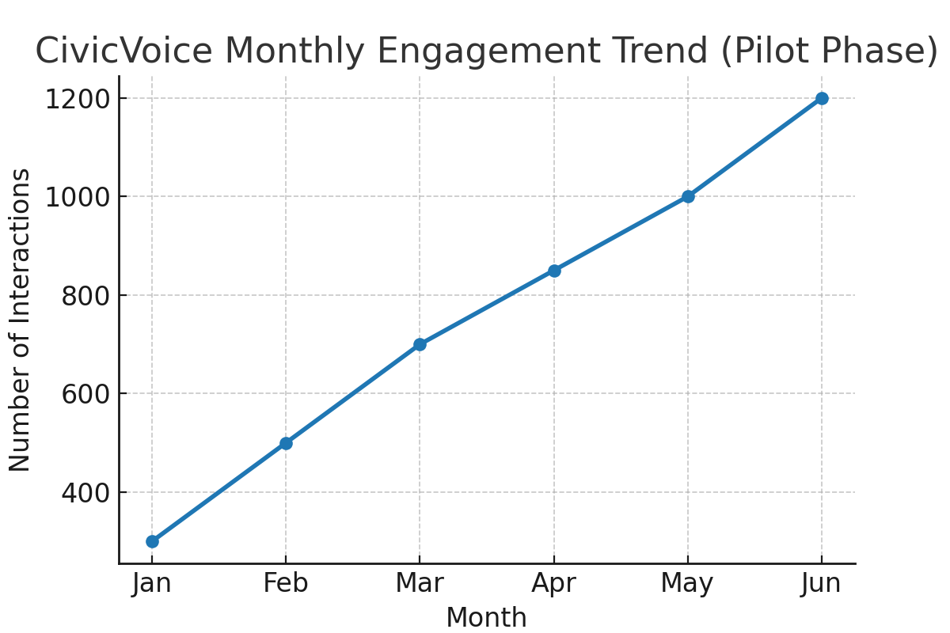

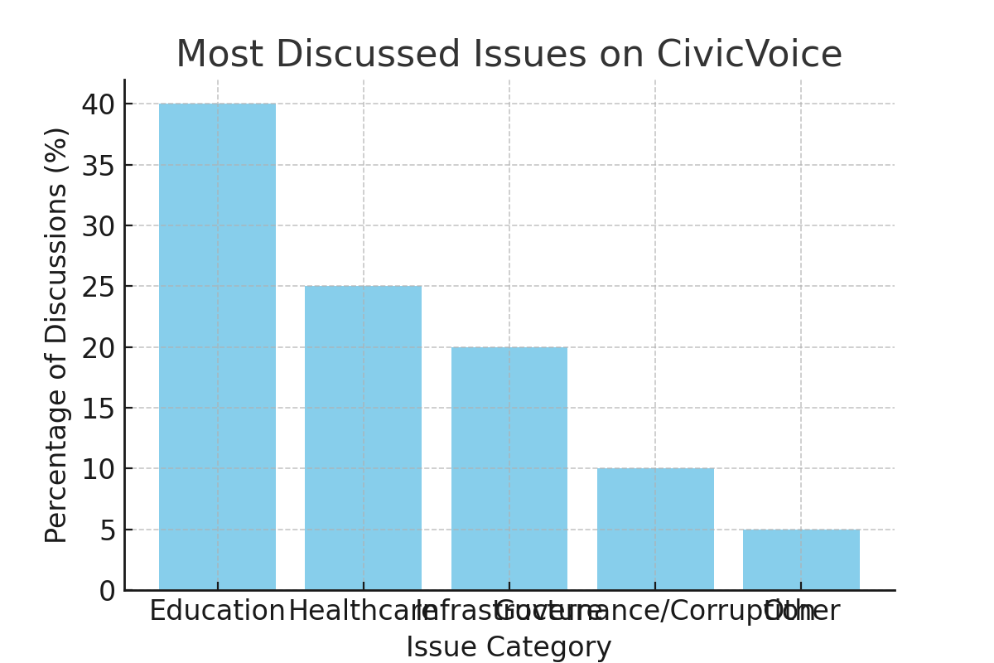

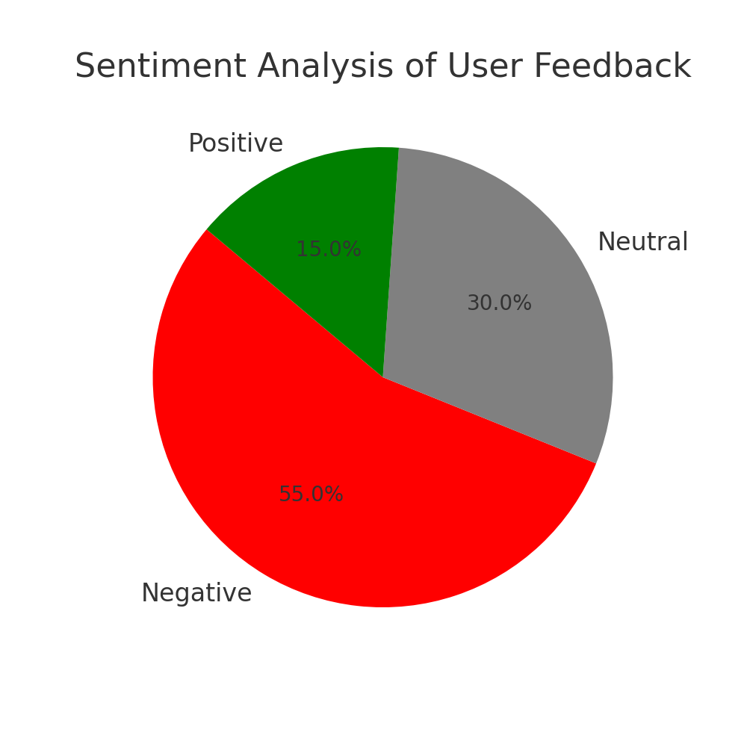

## **Conclusion**

The data research for CivicVoice highlights key insights:  
- Education and healthcare dominate public discussions (65%).  
- Sentiment is predominantly negative (55%), showing dissatisfaction with governance.  
- Engagement steadily increased, demonstrating adoption and responsiveness to real events.  
  
Importance: These insights confirm that CivicVoice can transform citizen voices into actionable evidence, providing policymakers and NGOs with data-driven guidance while enhancing transparency and accountability.

## **References**

World Bank. (2023). World Development Indicators. Retrieved from https://data.worldbank.org  
Kaggle. (2023). Public Sentiment and Civic Engagement Datasets. Retrieved from https://www.kaggle.com  
OECD. (2022). Open Government Data and Civic Participation. OECD Publishing.  
CivicTech Field Guide. (2023). Civic Engagement Platforms and Tools. Retrieved from https://civictech.guide  
UNDP. (2023). Digital Tools for Citizen Engagement. Retrieved from <https://www.undp.org>

# **Technology Review for CivicVoice**

## **Introduction**

The CivicVoice app leverages advanced technologies to improve governance, emergency response, and public service delivery in Liberia. Reviewing these technologies is essential to understand their capabilities, limitations, and suitability for addressing systemic governance challenges. The technologies under review include Natural Language Processing (NLP), Geospatial Data Systems, and Speech-to-Text technologies.

## **Technology Overview**

1. Natural Language Processing (NLP):  
- Purpose: To analyze citizen reports in both text and speech format.  
- Key Features: Sentiment analysis, keyword extraction, automatic routing, and text categorization.  
- Use in Relevant Fields: Widely applied in public safety, emergency call centers, chatbots, and governance platforms to process large volumes of citizen feedback efficiently.  
  
2. Geospatial Data Systems:  
- Purpose: To attach location metadata (GPS coordinates) to citizen reports.  
- Key Features: Mapping incident locations, tracking hotspots, forecasting trends.  
- Use in Relevant Fields: Disaster response systems, smart city planning, and public health monitoring.  
  
3. Speech-to-Text Technology:  
- Purpose: To convert voice-based reports into text for analysis.  
- Key Features: Real-time transcription, multi-accent recognition, and noise handling.  
- Use in Relevant Fields: Call centers, accessibility tools, and mobile-based reporting platforms.

## **Relevance to CivicVoice Project**

- NLP enables automated classification of incidents, reducing manual workload and response time.  
- Geospatial Data ensures accurate mapping of issues, which helps government agencies allocate resources more effectively.  
- Speech-to-Text increases accessibility, allowing citizens with varying literacy levels to contribute reports seamlessly.

## **Comparison and Evaluation**

- NLP vs Traditional Reporting Systems: Unlike manual systems, NLP speeds up classification and routing but requires quality datasets for training.  
- Geospatial Data vs Manual Mapping: Automated geotagging reduces human error but depends on smartphone GPS accuracy and internet connectivity.  
- Speech-to-Text vs Text-Only Systems: Increases inclusivity but may face challenges with local dialects and noisy environments.

## **Use Cases and Examples**

- AI in Public Safety: Studies show NLP enhances emergency response accuracy and reduces delays.  
- AI in Governance: UN research highlights the role of AI in optimizing resource allocation and decision-making, aligning directly with CivicVoice’s goals.  
- Real-World Example: Similar civic engagement platforms like SeeClickFix (USA) and FixMyStreet (UK) have demonstrated how technology-driven citizen reporting improves accountability.

## **Identified Gaps and Research Opportunities**

- Limited training datasets specific to Liberia may affect NLP accuracy.  
- Speech-to-text systems may struggle with local Liberian English and indigenous languages.  
- Infrastructure constraints (poor internet, limited smartphone penetration) may hinder full adoption.  
- Future research could explore offline-first architectures, AI models tuned for low-resource languages, and integration with USSD/SMS systems to broaden accessibility.

## **Conclusion**

The technologies powering CivicVoice—NLP, Geospatial Data, and Speech-to-Text—are highly relevant for addressing governance and emergency challenges in Liberia. They offer faster reporting, better resource allocation, and inclusive participation. However, successful implementation will require localized adaptations, improved infrastructure, and ongoing evaluation to ensure maximum impact.